Glory Entrusted
John 17:11-19


I am praying for them. I am not praying for the world but for those whom you have given me, for they are yours. John 17:9

¹¹And I am no longer in the world, but they are in the world, and I am coming to you. Holy Father, keep them in your name, which you have given me, that they may be one, even as we are one. ¹²While I was with them, I kept them in your name, which you have given me. I have guarded them, and not one of them has been lost except the son of destruction, that the Scripture might be fulfilled. ¹³But now I am coming to you, and these things I speak in the world, that they may have my joy fulfilled in themselves. ¹⁴I have given them your word, and the world has hated them because they are not of the world, just as I am not of the world. ¹⁵I do not ask that you take them out of the world, but that you keep them from the evil one. ¹⁶They are not of the world, just as I am not of the world. ¹⁷Sanctify them in the truth; your word is truth. ¹⁸As you sent me into the world, so I have sent them into the world. ¹⁹And for their sake I consecrate myself, that they also may be sanctified in truth.

I. Entrusted To The MANAGEMENT Of The Father
Holy Father, keep them in your name

A. For SINGLENESS of purpose
Holy Father, keep them in your name, which you have given me, that they may be one, even as we are one.

¹So if there is any encouragement in Christ, any comfort from love, any participation in the Spirit, any affection and sympathy, ²complete my joy by being of the same mind, having the same love, being in full accord and of one mind. ³Do nothing from selfish ambition or conceit, but in humility count others more significant than yourselves. Philippians 2:1-3

B. From SATANIC attack
I do not ask that you take them out of the world, but that you keep them from the evil one.

II. Entrusted With The MESSAGE Of The Truth

While I was with them, I kept them in your name, which you have given me. I have guarded them, not one of them has been lost except the son of destruction, that the Scripture might be fulfilled.” John 17:12

A. For the SATISFACTION of our souls
But now I am coming to you, and these things I speak in the world, that they may have my joy fulfilled in themselves.

⁷The law of the Lord is perfect, reviving the soul… ⁸the precepts of the Lord are right, rejoicing the heart… ¹⁰More to be desired are they than gold, even much fine gold; sweeter also than honey and drippings of the honeycomb. ¹¹Moreover, by them is your servant warned; in keeping them there is great reward. Psalm 19:7-11
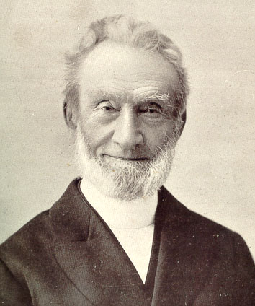

“I saw more clearly than ever, that the first great and primary business to which I ought to attend every day was, to have my soul happy in the Lord. The first thing to be concerned about was not, how much I might serve the Lord, how I might glorify the Lord; but how I might get my soul into a happy state, and how my inner man may be nourished. I saw that the most important thing I had to do was to give myself to the reading of the Word of God and to meditation on it.” George Muller

B. For the SANCTIFICATION of our lives
Sanctify them in the truth; your word is truth.

III. Entrusted For The MISSION Of The Kingdom
As you sent me into the world, so I have sent them into the world

For God did not send his Son into the world to condemn the world, but in order that the world might be saved through him. John 3:17

One Last Thought: Jesus entrusts us with glory to make us DISTINCT in order that the claims of the gospel make SENSE to the world to which we’re sent.

