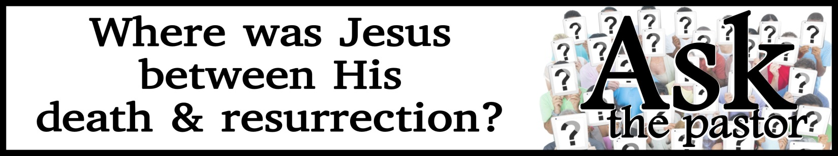

The Apostles' Creed
I believe in God, the Father almighty,
creator of heaven and earth.
I believe in Jesus Christ, his only Son, our Lord,
who was conceived by the Holy Spirit
and born of the virgin Mary.
He suffered under Pontius Pilate,
was crucified, died, and was buried;
he descended to hell.
The third day he rose again from the dead.
He ascended to heaven
and is seated at the right hand of God the Father almighty.
From there he will come to judge the living and the dead.
I believe in the Holy Spirit,
the holy catholic church,
the communion of saints,
the forgiveness of sins,
the resurrection of the body,
and the life everlasting. Amen.

I. The Heavenly REBELLION

- Angels were created BEFORE the earth

- The number of angels were INNUMERABLE

- Satan fell BEFORE he tempted Adam and Eve

- ONE-THIRD of the angels fell with him

- JESUS witnessed the fall of Satan

II. The Human SEDUCTION

III. The Earthly CORRUPTION

IV. The Decisive EXECUTION

V. The Definitive PROCLAMATION

VI. The Final CORONATION

